Multi-Branch Network System

|  |
| --- |
| **Name** |
| Abdullah Qanaan |

# Table of Contents:

Table of Contents

2.Work Breakdown Structure (WBS): **Error! Bookmark not defined.**

3. Table of Contents: 0

4. Introduction: 2

5. Objectives: 3

6. Assumptions: 3

7. Abdulrazaq Muhammad Mukhtar/TP073072 (KL Branch): 3

a. Logical Topology Design: 3

Floor Plan and Legends: 4

b. Justification of the Topology: 5

c. IP Addressing Scheme: 9

8. Abdullah Saleh Qanaan/TP075316 (Penang Branch) 11

a. Logical topology Design: 11

Floor Plan and legends: 11

b. Justification of the Topology: 12

c. IP Addressing scheme: 17

9. Abdullahi Mohamed/TP075796 (Ipoh Branch) 18

a. Logical topology Design: 18

b. Justification of the Topology: 18

c. IP Addressing scheme 23

10. Hamza Aboubaker Hassan/TP075796 (Malacca Branch) 25

a. Logical topology Design: 25

b. Justification of the Topology: 25

c. IP Addressing scheme: 25

11. Justification of the configuration techniques for different network devices 26

12. Conclusion: 28

13. References (APA format): 28

# 1. Introduction:

A developing start-up with offices in Kuala Lumpur, Penang, Ipoh, and Malacca, MapleTech aspires to improve network connectivity and security at every site. In order to implement and configure a networking solution, they have engaged the assistance of APU. Their needs and long-term company goals are intended to be efficiently met by this cooperative strategy.

APU is collaborating with MapleTech to create a unified network platform connecting their four offices in response to the start-up's request. The security and dependability of their local area networks are being improved as part of this endeavour. The suggested solution fits MapleTech's immediate needs as well as their long-term economic objectives by utilising the student talent of APU. To maintain transparency and give MapleTech a clear idea of the project's goals, this project will be thoroughly documented.

Amongst the various network topologies, one of them is the Star topology. Star topology is a configuration where every end device in a network is connected to the switch considered as the “main” device of this network. It can be easy to set up. However, the main issue is that if the switch does not function, the entire network goes down.

Another possible topology is called the Mesh topology. It is characterized by all the devices being interconnected with each other. The advantage relies specifically here, by realizing that if a computer doesn’t function anymore, there are still other ways to transmit data. This process is called as “redundant”. However, closing an eye on the technical capabilities, the drawbacks focus on the financial aspect of this type of network: it is expensive.

Another topology that we can set up is called the Wireless Mesh topology. In this network, a modem is connected to a switch, which in its turn is connected to either one wireless access point present in the network or all of wireless access points present. If connected to all of them, data flows through cable. If connected to one only, then data flows in a wireless method between the wireless access point connected to the switch and all the others. This setup is similar to the Mesh topology, in a sense that if a device crashes, the network can still function, however it also is very expensive adding the fact that it is time consuming.

We decide to apply and set up the Mesh topology for each network. The reason behind this choice is that we believe it is the most reliable. Even though it can be consuming, it seems by comparison to others less time consuming while being efficient at the same time. This will not affect the other computers and the overall network in each office of MapleTech company

# 2. Objectives:

Our objectives for this assignment are to:

* create a suitable LAN and WAN topology for the branch offices.
* Design an IP addressing scheme for efficient network management.
* Configure routers and switches to ensure optimal routing.
* Support the integration of IoT devices for automation.
* Allocate separate server rooms for specific services in each branch.

# 3. Assumptions:

For our design, we are assuming:

The company's primary need is reliable and secure communication between branches.

A static routing approach will suffice for routing packets between the branches.

The wired connections will adequately support the IoT devices' communication.

Each branch's server room will be physically secured to prevent unauthorized access.

The existing infrastructure can support the network additions and changes.

# 4. KL Branch:

The KL branch Network topology is centered around a star topology, it consists of 4 different departments which are IT (Information Technology), Marketing, Finance and Admin. Each department has one switch connected to the router with an Rj-45 copper straight-through cable connected to a gigabit ethernet port for faster internet speeds and to prevent bottlenecks. The KL branch has 34 hosts.

## a. Logical Topology Design:

## Floor Plan and Legends:

The branch consists of only 1 floor with 4 departments, The legend shows the indicates all devices shown in the diagram the IT department with the highest number of devices being the most spacious and the ad min with the least being the smallest.

## b. Justification of the Topology:

A Star topology was used for the KL branch network, with 4 switches connected to a central router. Because of several factors including:

- Scalability: Star topologies are highly scalable. As the start-up grows and more departments and hosts are added the network can be easily expanded by adding more switches and connecting them to the central router.

- Centralized Control: The central router in a star topology provides a centralized point of control for the entire network allowing things like monitoring network traffic, implementing advanced security measures, and troubleshooting issues.

- Isolation and Security: Each department is connected to the central router through its own switch. This isolation enhances network security by reducing the potential security risks spreading from one department to another and allows you to implement department specific security measures especially for departments containing sensitive information e.g., the finance and administrative departments.

- Redundancy: In the chance of a switch's failure in one department the rest of the networks in other departments will not be affected, allowing the functionality of other departments to remain the same.

- Physical Layout: Star topologies are suited to physical building layouts where departments are in various parts of the same building, while maintaining a clean and organized network infrastructure.

1. The IT department:

The IT department network address is 192.168.1.48. The subnet mask is 255.255.255.240 or ( /28) which gives 13 usable hosts. This subnet mask assigns 12 public IP addresses, from 192.168.1.49-192.168.1.62 assigned to devices within the network.

The IT department is the largest within the IP host's usable address and size with several types of network devices like the router and the switch, and it has end devices including PCs (Personal Computer) (Personal Computer), laptops, and servers and contains IOT devices like Air conditioners, Coffee machines, and light. With a star topology layout/design.

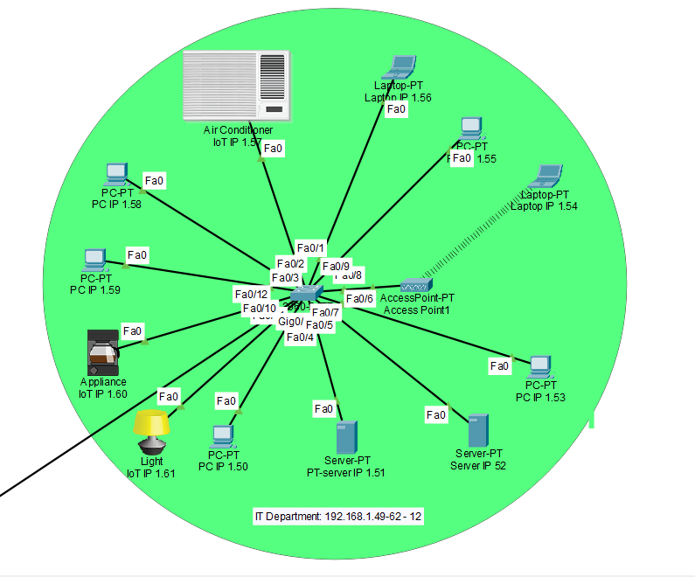

The IT department contains 1 router, 1 switch, 2 servers, 5 PCs, 1 air conditioner, 1 light, 2 laptops, an access point, and a Coffee machine. This room has an Air conditioner to maintain coolness and to make sure the server is not heated an access point to ensure wireless connectivity and multiple PCs and laptops for staff to use.

The Marketing Department:

The IT department network address is 192.168.1.64 The subnet mask is 255.255.255.240 or (/28) which gives 13 usable hosts. This subnet mask assigns 11 public IP addresses, from 192.168.1.65-192.168.1.78 assigned to devices within the network.

The Marketing department is the second largest within the IP host's usable address and size with several types of network devices including the switch, and it has end devices including PCs, laptops, and an access point and contains IOT devices like Air conditioners and light. With a star topology layout/design it offers centralized control and because the star topology design has proven to be dependable, safe, and simple to maintain.

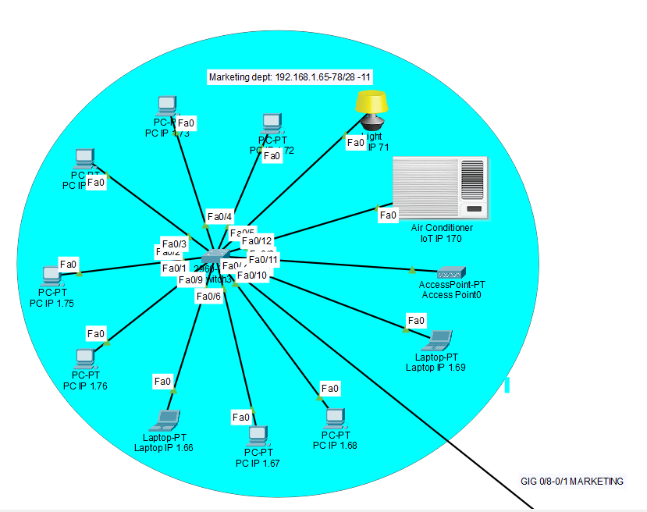

The Marketing department contains 1 switch, 7 PCs, 1 air conditioner, 1 light, 2 laptops, and an access point. This room has an Air conditioner to maintain coolness, an access point to ensure wireless connectivity and multiple PCs and laptops for staff to use.

The Admin Department:

The IT department network address is 192.168.1.136 The subnet mask is 255.255.255.248 or (/29). Which gives 6 usable hosts, from the range 192.168.1.137 to 192.168.1.142 hosts. assigned to devices within the network.

The admin department is the second smallest within the IP host's usable address and size with several types of network devices including the switch, and it has end devices including PCs, laptops, and an access point and contains IOT devices like Air conditioners, lights, and fans. With a star topology layout/design, it offers centralized control and, because it offers centralized control and has proven to be dependable, safe, and simple to maintain.

The admin department contains 1 switch, 1 PCs, 1 air conditioner, 1 light, 1 laptop, and an access point. This room has an Air conditioner to maintain coolness, an access point to ensure wireless connectivity and a laptop and PC (Personal Computer) for the admin to use.

The Finance Department:

The IT department network address is 192.168.1.144 The subnet mask is 255.255.255.248 or (/29). Which gives 5 usable hosts, from the range 192.168.1.145 to 192.168.1.150 hosts. assigned to devices within the network.

The finance department is the smallest within the IP host's usable address and size with several types of network devices including the switch, and it has end devices including PCs, laptops, and a printer and contains IOT devices like Air conditioners and fans. With a star topology layout/design, it offers centralized control and, because it offers centralized control and has proven to be dependable, safe, and simple to maintain.

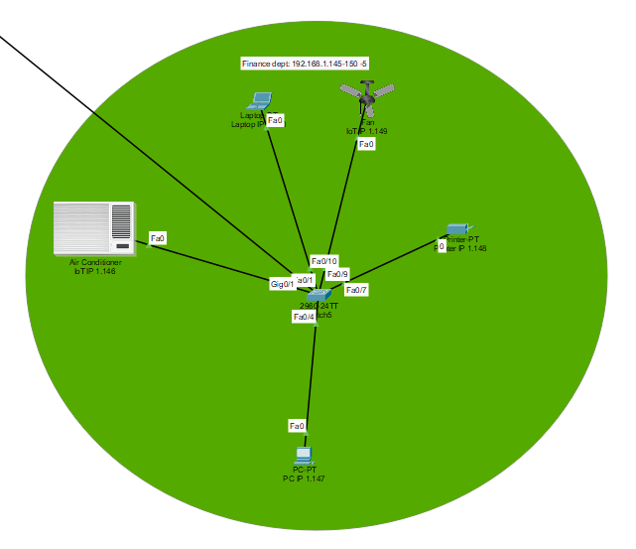

The finance department contains 1 switch, 1 PC, 1 air conditioner, 1 printer, 1 laptop, and 1 fan. This room has an Air conditioner to maintain coolness, a printer to allow the financial officer to print financial documents and does not use an access point to improve general security of the network in that department.

## c. IP Addressing Scheme:

| **Device** | **Interface** | **Network Address** | **IP Address** | **Usable Address Range** | **Broadcast Address** | **Default Gateway** |
| --- | --- | --- | --- | --- | --- | --- |
| **Router –**  **KL** | **Giga0/6**  IT | 192.168.1.48 | 192.168.1.49 | 192.168.1.49-62 | 192.168.1.63 | 192.168.1.49 |
| **Giga0/8**  Marketing | 192.168.1.64 | 192.168.1.65 | 192.168.1.65-78 | 192.168.1.79 | 192.168.1.65 |
| **Giga0/9**  Admin | 192.168.1.136 | 192.168.1.137 | 192.168.1.137-142 | 192.168.1.143 | 192.168.1.137 |
|  | **Giga0/7**  Finance | 192.168.1.144 | 192.168.1.145 | 192.168.1.145-150 | 192.168.1.151 | 192.168.1.145 |

# 5.Penang Branch

The Penang branch network topology is based on a star topology, and it has 4 different departments which are IT, finance, sales, and marketing. Each department has one switch that is connected to the router with an Rj-45 copper straight-through which is connected to a gigabitethernet port. The Penang branch has in total of 32 hosts.

## Logical topology Design:

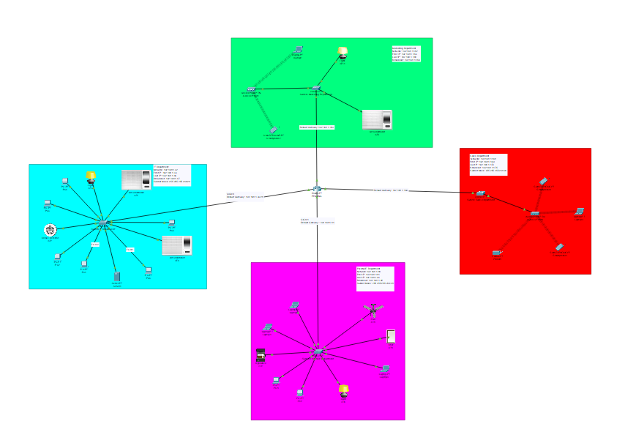

## Floor Plan and legends:

The branch has only 1 floor with 4 departments when we go through the entrance we going to see on our right-hand side, the first department would be the sales department with two doors which is considered the second smallest department in the branch, at the same side there is the finance department with one of the biggest departments. In the end right corner, there would be the restroom. On the opposite side, the first thing that would be with the smallest department is the marketing room because it has the lowest number of hosts. Then the final section and the largest department is IT, by having the most important things such as the router and server. The floor contains 14 different types of network devices and end devices, and each one of them has its own symbol, every symbol is explained in the legend schedule.

## Justification of the Topology:

The Penang branch network used a star topology, with four switches linked to a central router. Because of a number of reasons, such as:

- Centralized Control: In a star topology, the central router acts as a single point of control for the whole network, enabling functions like advanced security implementation, network traffic monitoring, and problem-solving.

- Security: A switch from each department connects to the main router. By lowering the possibility of security risks transferring from one department to another, this isolation improves network security and enables you to put department-specific security measures in place, particularly for departments that handle sensitive data.

1. The first department: IT

The IT department network address is 192.168.1.32. The subnet mask is 255.255.255.240 or ( /28) which gives 13 usable hosts. This subnet mask assigns 13 public IP addresses, from 192.168.1.33 to 192.168.1.46, to devices within the network.

The IT department is the largest within the IP host's usable address and size with different types of network devices like the router and the switch, and it has end devices such as air conditioner, server, PC, smoke detector, and light. With a star topology layout/design.

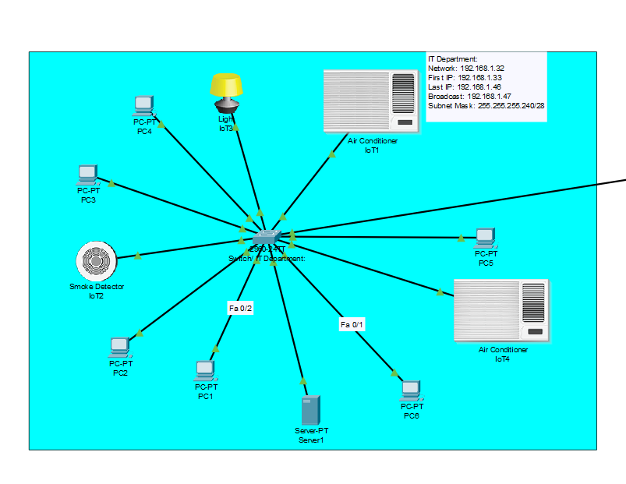

The IT department contains 1 router, 1 switch, 1 server, 6 PCs, 2 air conditioners, 1 light, and a smoke detector. This room needs a cooling system to make sure the server is not heated up by using 2 aircon and for safety, there is a smoke detector to check if there is any smoke coming out from the server or the router.

2. The second department: Finance

The network address for the Finance division is 192.168.1.80. The subnet mask is 255.255.255.240, or (/28) and there are 13 viable hosts as a result. 13 public IP addresses, ranging from 192.168.1.81 to 192.168.94, are assigned by this subnet mask.

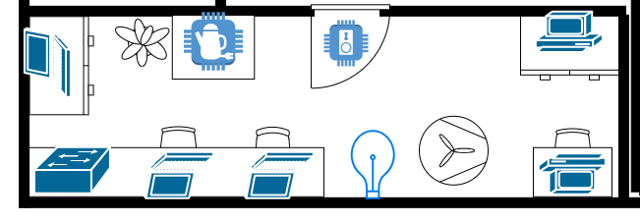

Because star topology is dependable, scalable, safe, and simple to maintain, we employed it for the finance department, as depicted in the image. The department has 1 switch, 3 laptops, 2 PCs, 1 light, 1 fan, an appliance, and a smart door. In addition, we put a smart door to ensure excellent security, which is crucial for the finance area.

3. The third department: Sales

The sales department has one of the lowest IP hosts in the branch. Using this network address 192.168.1.168, and a subnet mask 255.255.255.248 or (/29). Which gives 6 usable hosts, from the range 192.168.1.169 to 192.168.1.174 hosts.

The sales department only uses wireless end devices. The wireless access point increases user comfort by giving users the freedom to connect portable devices like laptops and cell phones without the necessity of physical wires. The access point connects to the switch, providing wireless connection to the devices that require it, such as printers, smartphones, and laptops. For Security In general, wired connections are seen as being more secure than wireless ones however, wireless devices are more flexible and convenient.

4. The fourth department: Marketing

The marketing department's network within the branch has a relatively low number of available IP hosts. This network is configured with the IP address 192.168.1.152 and a subnet mask of 255.255.255.248, represented as (/29). With this subnetting, it provides 6 usable hosts, within the range from 192.168.1.153 to 192.168.1.158.

The switch is connected to an access point, the access point is connected to two end devices (a wireless smartphone and a laptop), and there are additional devices like an air conditioner and a light connected to the switch. If there are problems with the wireless connection, individuals can maintain their access to the network and the internet using the wired connection.

## IP Addressing scheme:

| **Device** | **Interface** | **Network Address** | **IP Address** | **Usable Address Range** | **Broadcast Address** | **Default Gateway** |
| --- | --- | --- | --- | --- | --- | --- |
| **Router –**  **Penang** | **Giga0/0**  IT | 192.168.1.32 | 192.168.1.33 | 33-46 | 192.168.1.47 | 192.168.1.33 |
| **Giga0/1**  FINANCE | 192.168.1.80 | 192.168.1.81 | 81-94 | 192.168.1.95 | 192.168.1.81 |
| **Giga0/3**  Marketing | 192.168.1.152 | 192.168.1.153 | 153-158 | 192.168.1.159 | 192.168.1.153 |
|  | **Giga0/2**  Sales | 192.168.1.168 | 192.168.1.169 | 169-174 | 192.168.1.175 | 192.168.1.169 |

# 6. Ipoh Branch

## Logical topology Design:

## Justification of the Topology:

The Ipoh branch network topology is based on a star topology, and it has 4 different departments which are IT, finance, sales, and marketing. Each department has one switch that is connected to the router with a Rj-45 copper straight-through which is connected to a gigabitEthernet port. The Ipoh branch has in total of 34 hosts.

**Floorplan:**

The branch has only 1 floor with 4 departments when we go through the entrance we going to see on our right-hand side, the first department would be the sales department with two doors which is considered the second smallest department in the branch, at the same side there is the finance department with one of the biggest departments. In the end right corner, there would be the restroom. On the opposite side, the first thing that would be with the smallest department is the marketing room because it has the lowest number of hosts. Then the final section and the largest department is IT, by having the most important things such as the router and server. The floor contains 14 different types of network devices and end devices, and Floorplan.

**The first department: IT**

The IT department network address is 192.168.1.0.The subnet mask is 255.255.255.240 or ( /28) which gives 13 usable hosts. This subnet mask assigns 13 public IP addresses, from 192.168.1.1to 192.168.1.14, to devices within the network.

The IT department is the largest within the IP host's usable address and size with different types of network devices like the router and the switch, and it has end devices such as air conditioner, server, PC, smoke detector, and light. With a star topology layout/design.

1 switch, 1 server, 5PCs, 2 air conditioners, 1 light, and 2 smoke detectors. This room needs a cooling system to make sure the server is not heated up by using 2 aircon and for safety, there is 2 smoke detectors to check if there is any smoke coming out from the server or the router.

**The second department: Finance**

The network address for the Finance division is 192.168.1.97. The subnet mask is 255.255.255.240, or (/28) and there are 13 viable hosts as a result. 8 public IP addresses, ranging from 192.168.1.97 to 192.168.110, are assigned by this subnet mask.

Because star topology is dependable, scalable, safe, and simple to maintain, we employed it for the finance department, as depicted in the image. The department has 1 switch, 1 laptops, 2 PCs, 1 light, 1 fan, an appliance, and a smart dooralso 1 smoke detector. In addition, we put a smart door to ensure excellent security, which is crucial for the finance area.

**The third department: Sales**

The sales department has one of the lowest IP hosts in the branch. Using this network address 192.168.1.128, and a subnet mask 255.255.255.248 or (/29). Which gives 6 usable hosts, from the range 192.168.1.129 to 192.168.1.134 hosts.

connections are seen as being more secure than wireless ones however, wireless devices are more flexible and convenient.

The sales department only uses wireless end devices. The wireless access point increases user comfort by giving users the freedom to connect portable devices like laptops and cell phones without the necessity of physical wires. The access point connects to the switch, providing wireless connection to the devices that require it, such as printers, smartphones, and laptops. For Security In general, wired

**The fourth department: Marketing**

The marketing department's network within the branch has a relatively low number of available IP hosts. This network is configured with the IP address 192.168.1.176 and a subnet mask of 255.255.255.248, represented as (/29). With this subnetting, it provides 5 usable hosts, within the range from 192.168.1.177 to 192.168.1.182.

The switch is connected to an access point, the access point is connected to two end devices (a wireless smartphone and a laptop), and there are . If there are problems with the wireless connection, individuals can maintain their access to the network and the internet using the wired connection.

## IP Addressing scheme

| **Device** | **Interface** | **Network Address** | **IP Address** | **Usable Address Range** | **Broadcast Address** | **Default Gateway** |
| --- | --- | --- | --- | --- | --- | --- |
| **Router –** | **Gig 0/0** | 192.168.1.0 | 192.168.1.1 | 1-14 | 192.168.1.15 | 192.168.1.1 |
| **Gig 1/0** | 192.168.1.96 | 192.168.1.97 | 97-110 | 192.168.1.111 | 192.168.1.97 |
| **Gig 2/0** | 192.168.1.128 | 192.168.1.129 | 129-134 | 192.168.1.135 | 192.168.1.129 |
|  | **Gig 3/0** | 192.168.1.176 | 192.168.1.177 | 177-182 | 192.168.1.183 | 192.168.1.177 |

# 7. Malacca Branch

## Logical topology Design:

## Justification of the Topology:

A router is assembled at the edge of the LAN for Malacca Branch in order to connect with the other branches by WAN. This router is hooked to 4 switches in this LAN. Each of them is at the edge of a subnet. The choice of this is justified by the fact that there are 4 departments in Malacca Branch (IT, Finance, Sales, Marketing), hence this makes it hierarchically a more understandable and neat assembly. In the IT Department, 12 hosts are hooked to the switch. In the Finance department, 4 hosts are set up. In the Sales department, 5 hosts are hooked and in the Marketing department, 11 hosts are set.

All the cables used are the same type: the Copper-Straight Through. Indeed, all the connections: Swith-Router, Switch-PCs, Switch-Server, Switch-IoT devices are of different types, which according to the Rule of thumb justifies the use of this cable.

In the IT department, there is one server in addition to 3 IoT devices which are a fan, a webcam and a light. The fan serves to cool the room. The webcam is here to manage the security of the department, and the light regulates the lighting of the room.

## IP Addressing scheme:

| 1. **Device** | **Interface** | **Network Address** | **IP Address** | **Usable Address Range** | **Broadcast Address** | **Default Gateway** |
| --- | --- | --- | --- | --- | --- | --- |
| **Router –** |  | 192.168.1.16 | 192.168.1.17 | 192.168.1.17-30 | 192.168.1.31 | 192.168.1.17 |
|  | 192.168.1.112 | 192.168.1.113 | 192.168.1.113-126 | 192.168.1.127 | 192.168.1.113 |
|  | 192.168.1.160 | 192.168.1.161 | 192.168.1.161-166 | 192.168.1.167 | 192.168.1.161 |
|  |  | 192.168.1.184 | 192.168.1.185 | 192.168.1.185-190 | 192.168.1.191 | 192.168.1.185 |

First – 16/28

Second- 112/28

Third- 160/29

Fourth- 184/29

The slashes denote the subnet mask

8. Justification of the configuration techniques for different network devices.

* 1. Brief explanation of configuration on network devices with suitable evidence (supported with screenshot)

1. Router:

* Static routing: Static routing was implemented because the network was relatively small and stable with few components. Static routing simplifies the process of routing and is more efficient when the network topology does not change often.
* Network Address Translation (NAT): “Network Address Translation (NAT) conserves IP addresses by enabling private IP networks using unregistered IP addresses to go online. Before NAT forwards packets between the networks it connects, it translates the private internal network addresses into legal, globally unique addresses”.
* RIP V2: RIP V2 is the successor of version 1 it is used because of its simplicity (easy to manage and configure for small to medium sized networks), compatibility (Almost all router manufacturers support RIPV2), Route summarization: RIPV2 allows for route summarization which can be used to reduce the size of the routing table making it more efficient and also allows for authentication allowing for better network security.

   
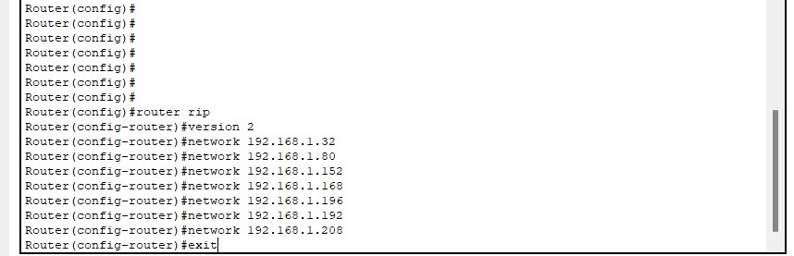   
   
   
   
   
   
2. Hosts:

* Static IP Address Assignment: Manually configuring IP addresses allows us to assign IP to every host manually. This is helpful when you want to ensure certain devices have the same IP addresses, which helps for certain network services that require fixed IP Addresses.
* Control over Network Settings: Manual configuration gives the network administrator full control over network settings, including IP Addresses, subnet masks, default gateways and DNS server addresses.

* Security: configuring IP addresses manually reduces security risks like getting the DHCP server compromised and threat actors stealing all IP addresses in the network.

3. Overall Network Configuration:

* Monitoring: Using network monitoring tools to track overall network monitoring tools to track networking performance and integrity, detecting issues and analyzing security risks.
* Backup and Redundancy: Always backing up configuration settings on important devices like switches, routers and servers in case of disaster recovery.

# 9. Conclusion:

The goals for this project involve making the right LAN and WAN designs, setting up IP addresses, configuring routers and switches, supporting IoT devices. The four branches involved in the Cisco Packet Tracer assignment have successfully designed and configured the networked system between them. Every department has been given a unique subnet and IP address range by using VLSM, which are linked to a switch by using a Rj-45 copper straight-through which is connected to a fast ethernet port. Every switch has a router linked to it, which allows for routing between deafferent networks. Those networks use various end devices and network devices such as switches, routers, computers, printers, etc.

# 10. References (APA format):

HI Tech. (2021, December 18). *Router Rip Version 2 with VLSM* [Video]. YouTube. <https://www.youtube.com/watch?v=iyZRZc0iH_8>

East Charmer. (2021, March 27). *Easy VLSM Subnetting | Step by step VLSM* [Video]. YouTube. <https://www.youtube.com/watch?v=IgthYZ9N1vs>

*NetAcad Course UI*. (n.d.). <https://contenthub.netacad.com/itn-dl/11.8.1>

PowerCert Animated Videos. (2021, September 30). *Subnet mask - explained* [Video]. YouTube. <https://www.youtube.com/watch?v=s_Ntt6eTn94>

Akram TVTC. (2019, January 17). *شرح طريقة تقسيم الشبكة باستخدام VLSM* [Video]. YouTube. <https://www.youtube.com/watch?v=ZVzHhd1q9v0>

*Star topology*. (2023, March 5). <https://www.computerhope.com/jargon/s/startopo.htm>

GeeksforGeeks. (2022). Advantages and Disadvantages of Star Topology. *GeeksforGeeks*. <https://www.geeksforgeeks.org/advantages-and-disadvantages-of-star-topology/>

KDK 3 BLADE CEILING FAN 150CM M60SG-BK (BLACK) | COOLING & HEATING.

(n.d.). Fastener Group Pte Ltd. Retrieved October 27, 2023, from <https://www.fastener.com.sg/household-office/electrical-and-lighting/fans/kdk-3-blade-ceiling-fan-150cm-m60sg-bk-black/>

Andy. (2009, March 28). Anti Earth Hour: SWITCH ON THE LIGHTS!!! Wallpaper. Anti Earth Hour.

<https://antiearthhour.blogspot.com/2009/03/switch-on-lights-wallpaper.html>

Flowchart Maker & Online Diagram Software. (n.d.). App.diagrams.net. Retrieved October 27, 2023, from

<https://app.diagrams.net/#G1ujC3mgnETE5lsQg074vNqWoUeYWVXcvD>

Mesh Topology In Cisco Packet Tracer | Network Topology | #meshtopology #CiscoPacketTracer #youtube. (n.d.). [Www.youtube.com](http://Www.youtube.com). Retrieved October 27, 2023, from [www.youtube.com/watch?v=ZPrhJul6h5Y](http://www.youtube.com/watch?v=ZPrhJul6h5Y)

Network topology types (Bus, Star, Ring, Mesh, Hybrid, Logical, Physical) | TechTerms. (n.d.). [Www.youtube.com](http://Www.youtube.com). Retrieved October 27, 2023, from

<https://www.youtube.com/watch?v=e0CWszGpgAE&t=227s>

Network Topologies (Star, Bus, Ring, Mesh, Ad hoc, Infrastructure, & Wireless Mesh Topology). (2018). [YouTube Video]. In *YouTube*

<https://www.youtube.com/watch?v=zbqrNg4C98U>